**Explore ML – Week 1**

[**Advanced Features of Python**](https://www.notion.so/Advanced-Features-of-Python-e39b0d09f55d4d609a1c825d54b2ac80)

1 )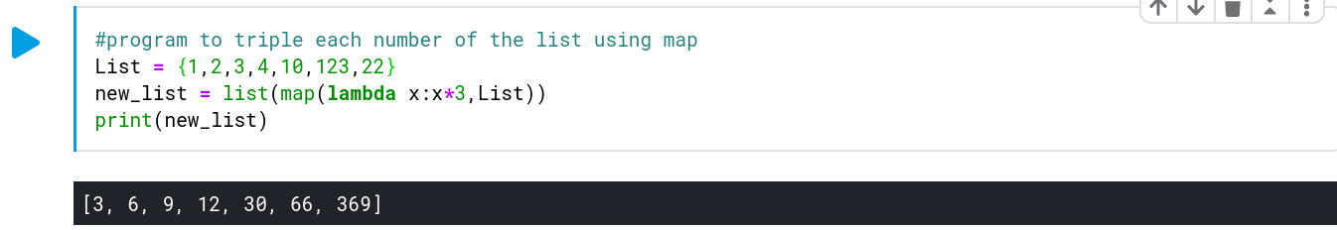 For each number in the list, the output is mapped to the input index. Lambda is used to perform a small function here i.e. increasing each I/P value by 3.

2)

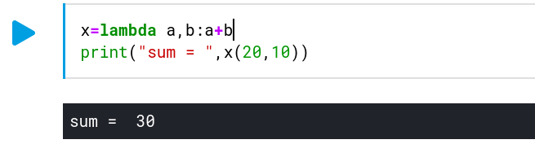

Another example of the lambda notation of functions. ‘a’ and ‘b’ are the identifiers created to take in the actual parameters passed when calling the function.

**Visualization**

1)

Here we print the 5 number summary for iris dataset using 5 variables – Min, Max, Mean(2nd Quartile), 1st Quartile( 25 %) and 3rd Quartile (75%).

IRIS has 5 attributes - sepal length in cm - sepal width in cm - petal length in cm - petal width in cm

- class: - Iris-Setosa - Iris-Versicolour - Iris-Virginica

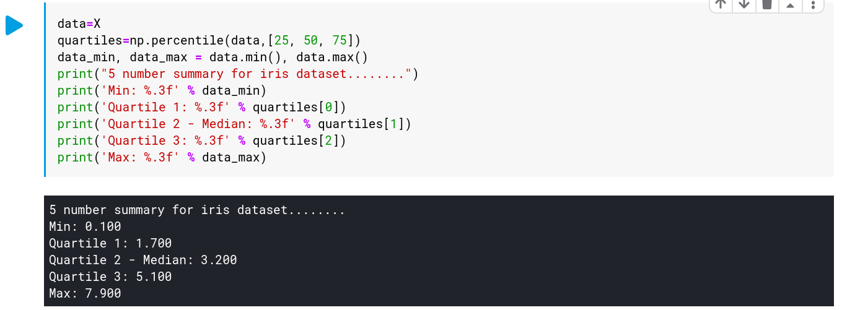

2)